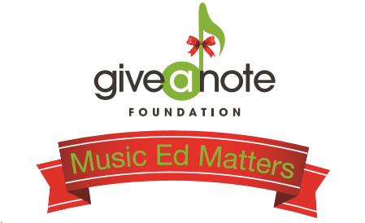

Winery Script for Participant:
Good Afternoon, thanks for coming out to [Winery/Brewery name] on this chilly November afternoon to enjoy some great wine and great music! My name is [Your name] and I am here today on behalf of the Give a Note Foundation. I wanted to tell you about the drink special [Winery/Brewery name] is offering today and why it’s being offered. November is national philanthropy month and [Winery/Brewery name] has decided to join me in promoting music education. The Give a Note Foundation recently launched a Music Ed Matters Campaign in the hope to increase awareness and donations for the foundation during the giving season. As part of this campaign, [Winery/Brewery name] is offering a $5 drink special of [drink]. For every drink special purchased [Winery/Brewery name] will be making a donation to the Give a Note Foundation. The funds donated will go towards Give a Note Foundation programs and grants to schools in underserved communities across the country. Music programs across the nation are in jeopardy of being cut or stripped of funding and resources. Give the gift of music today and enjoy some great wine while you’re at it! Please share your support by posting on social media using the hashtag #MusicEdMatters

For those of you who weren’t here earlier, I wanted to let you know real quick about the drink special that is running today! The Give a Note Foundation based whose mission is to nurture, grow, and strengthen music education opportunities, recently launched a Music Ed Matters Campaign in the hopes to increase awareness and donations for the foundation during the giving season. As part of this campaign, [Winery/Brewery name] is offering a $5 drink special. For every drink special purchased [Winery/Brewery name] will be making a donation to the Give a Note Foundation. The funds donated will go towards Give a Note Foundation programs and grants to schools in underserved communities across the country. Give the gift of music and enjoy some great while you’re at it! And don’t forget to spread the word. Use the hashtag #MusicEdMatters to share your support. Please feel free to come chat with me about Give a Note!

I hope you all have been enjoying the music today. Give it up for [Musician/Band name]! In case you haven’t heard yet, [Winery/Brewery name] is offering a $5 drink special today. [Winery Name] has decided to join me in promoting music education. For every drink special purchased [Winery/Brewery name] will be making a donation to the Give a Note Foundation. The funds donated will go towards Give a Note Foundation programs and grants to schools in underserved communities across the country. Give the gift of music today and enjoy yourself a glass of wine! Be sure to spread the word. Use the hashtag #MusicEdMatters on social media to share your support. And please feel free to come chat with me about Give a Note’s mission.

As the day is coming to a close, this is one last reminder to take advantage of the drink special being offered today. For every drink special purchased [Winery/Brewery name] will be making a donation to the Give a Note Foundation. The funds donated will go towards Give a Note Foundation programs and grants to schools in underserved communities across the country. Give the gift of music. It can change a student’s life! If you are interested in learning more about Give a Note, come visit me over [Where you are set up] Also, be sure to spread the word. Use the hashtag #MusicEdMatters to share your support!

