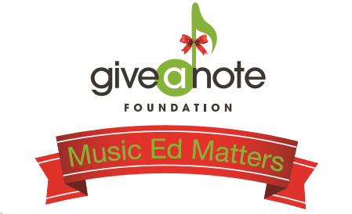

Winery Script for Owner/Staff Member:
Good Afternoon, thanks for coming out to [Winery/Brewery name] on this chilly November afternoon to enjoy some great wine and great music! I am _____ the owner/staff member. I wanted to tell you about the drink special we are offering today and why it’s being offered. November is national philanthropy month and we have decided to take part! The Give a Note Foundation based out of Reston, Virginia has launched a Music Matters Campaign with the hope to increase awareness and donations for the foundation during the giving season. As part of this campaign, we are offering a $5 drink special of [drink]. For every drink special purchased [Winery/Brewery name] will be making a donation to the Give a Note Foundation. The funds donated will go towards Give a Note Foundation programs and grants to schools in underserved communities across the country. Music programs across the nation are in jeopardy of being cut or stripped of funding and resources. Give the gift of music today and enjoy some great wine while you’re at it! Please share your support by posting on social media using the hashtag #MusicEdMatters.

