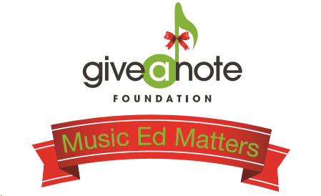

Winery Script for Musician:
Good Afternoon, thanks for coming out to [Winery name] on this chilly November afternoon to enjoy some great wine and hopefully equally great music (joke). I wanted to tell you about the drink special [Winery/Brewery name] is running today and why it’s being offered. November is national philanthropy month! The Give a Note Foundation based out of Reston, Virginia has launched a Music Ed Matters Campaign with the hope to increase awareness and donations for the foundation during the giving season. As part of this campaign, [Winery/Brewery name] is offering a $5 drink special. For every drink special purchased [Winery/Brewery name] will be making a donation to the Give a Note Foundation. The funds donated will go towards Give a Note Foundation programs and grants to schools in underserved communities across the country. Music programs across the nation are in jeopardy of being cut or stripped of funding and resources. Give the gift of music today and enjoy some great wine while you’re at it! Please share your support by posting on social media using the hashtag #MusicEdMatters

For those of you who weren’t here earlier, I wanted to let you know real quick about the drink special that is running today! The Give a Note Foundation based out of Reston, Virginia whose mission is to nurture, grow, and strengthen music education opportunities, launched a Music Ed Matters Campaign in the hopes to increase awareness and donations for the foundation during the giving season. As part of this campaign, [Winery/Brewery name] is offering a $5 drink special. For every drink special purchased [Winery/Brewery name] will be making a donation to the Give a Note Foundation. The funds donated will go towards Give a Note Foundation programs and grants to schools in underserved communities across the country. Give the gift of music and enjoy some great wine while you’re at it! And don’t forget to spread the word. Use the hashtag #MusicEdMatters to share your support.

I hope you all have been enjoying yourselves today. In case you haven’t heard yet, [Winery Name] is offering a $5 drink special today. [Winery/Brewery name] has decided to join the Give a Note Foundation and promote and support music education. For every drink special purchased [Winery/Brewery name] will be making a donation to the Give a Note Foundation. The funds donated will go towards Give a Note Foundation programs and grants to schools in underserved communities across the country. Give the gift of music today and enjoy yourself a glass of wine! Be sure to spread the word. Use the hashtag #MusicEdMatters on social media to share your support.

As our time is coming to an end, this is one last reminder to take advantage of the drink special being offered today. For every drink special purchased [Winery/Brewery name] will be making a donation to the Give a Note Foundation. The funds donated will go towards Give a Note Foundation programs and grants to schools in underserved communities across the country. Give the gift of music. It can change a student’s life, it changed mine! Be sure to spread the word. Use the hashtag #MusicEdMatters to share your support!

