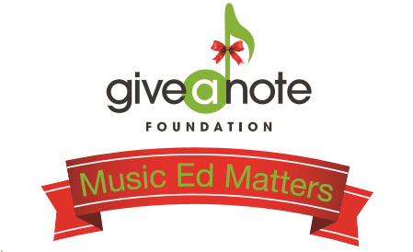

Script for Participant:
Good Afternoon, thanks for coming out to [Business name] on this chilly November afternoon to enjoy some great food and great music! My name is [Your name] and I am here today on behalf of the Give a Note Foundation. I wanted to tell you about the drink special [Business Name] is offering today and why it’s being offered. November is national philanthropy month and [Business Name] has decided to join me in promoting music education. The Give a Note Foundation recently launched a Music Ed Matters Campaign in the hope to increase awareness and donations for the foundation during the giving season. As part of this campaign, [BusinessName] is offering a $10 meal special of meal. The proceeds raised today will go towards Give a Note Foundation programs and grants to schools in underserved communities across the country. Music programs across the nation are in jeopardy of being cut or stripped of funding and resources. Give the gift of music today and enjoy some great food while you’re at it! Please share your support by posting on social media using the hashtag #MusicEdMatters

For those of you who weren’t here earlier, I wanted to let you know real quick about the drink special that is running today! The Give a Note Foundation based whose mission is to nurture, grow, and strengthen music education opportunities, recently launched a Music Ed Matters Campaign in the hopes to increase awareness and donations for the foundation during the giving season. As part of this campaign, [Business name] is offering a $10 meal special. Give the gift of music and don’t forget to spread the word. Use the hashtag #MusicEdMatters to share your support. Please feel free to come chat with me about Give a Note!

I hope you all have been enjoying the music today. Give it up for [Musician/Band name]! In case you haven’t heard yet, [Business Name] is offering a $10 meal special today. [Business Name] has decided to join me in promoting music education. The proceeds raised today will go towards Give a Note Foundation programs and music grants to schools in underserved communities across the country. Give the gift of music today and be sure to spread the word. Use the hashtag #MusicEdMatters on social media to share your support. And please feel free to come chat with me about Give a Note’s mission.

As the day is coming to a close, this is one last reminder to take advantage of the meal special being offered today. Proceeds go to the Give a Note Foundation to provide music grants to schools in underserved communities across the country. Give the gift of music. It can change a student’s life! If you are interested in learning more about Give a Note, come visit me over [Where you are set up] Also, be sure to spread the word. Use the hashtag #MusicEdMatters to share your support!

